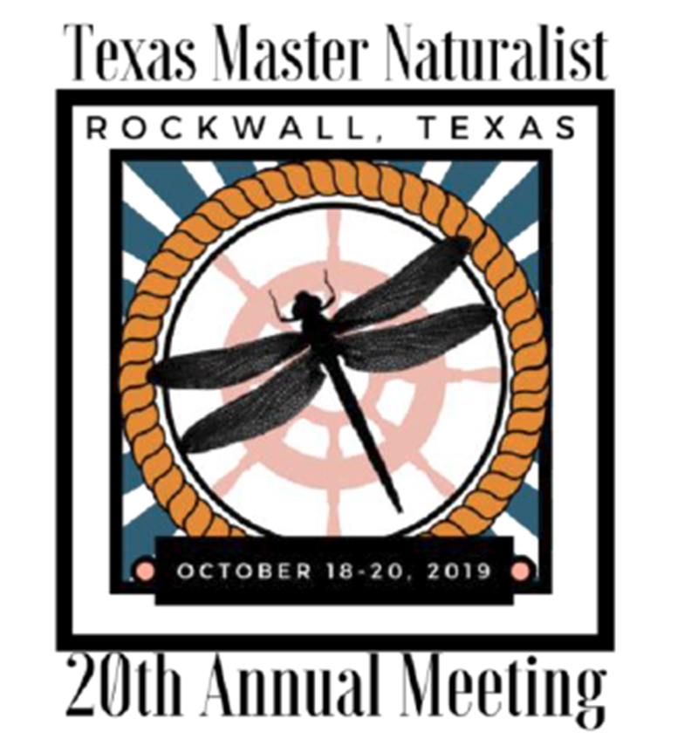
Request for Donation
Texas Master Naturalist 20th Annual Meeting
October 18-20, 2019
Hilton Dallas/Rockwall Lakefront

We are seeking donations for the Silent Auction to be held during the Texas Master Naturalist 20th Annual Meeting. This event provides educational seminars and networking opportunities to over 700 Texas Master Naturalist (TMN) volunteers from across the state. These attendees represent the 10,000 volunteers in the 48 chapters where they serve their local communities across the state.

Please consider donating products, gift cards, or making a financial contribution to benefit this statewide organization. The North Texas chapter, leading the silent auction this year is a tax-exempt entity (a 501 (c)(3)). Your donation will receive recognition and be displayed at the Silent Auction during the entire 3 days of the conference.

About the Texas Master Naturalist Program
The Texas Master Naturalist program is a natural resource-based volunteer program sponsored statewide by the Texas A&M AgriLife Extension Service and the Texas Parks and Wildlife Department. The mission of the program is to develop a corps of well-trained volunteers to provide education, outreach and service dedicated toward the beneficial management of natural areas and resources within their communities for the State of Texas. These volunteers then provide service in connection with state parks and natural areas, scouting programs, nature centers, nature education in schools, maintenance of public forests/parks, water quality monitoring, and numerous other programs to conserve and promote the natural resources of the state. To learn more about the program, please visit https://txmn.org/

Sponsorship and Vendor opportunities are available also.
With many levels of sponsorship available, organizations or individuals wishing to make a donation instead of donating an item may do so as an Annual Meeting sponsor. There are both general sponsorships and specific event-oriented sponsorships available (such as sponsoring a campfire evening event or a coffee break in the daytime). More information on Sponsorships can be found: https://txmn.org/files/2019/03/Sponsors-for-2019-TMN-Annual-Meeting.pdf

Nature-related vendors and organizations are invited to attend the event to sell products or programs. The vendor booths will be located in the main conference hallway at the Hilton Rockwall Lakefront. Booths will be limited to those vendors providing educational materials, selling naturalist related items (artwork, jewelry, tools, etc.) or partnership programming opportunities for our Texas Master Naturalists. Vendors will receive one 6-foot table and two chairs. Electricity and other display needs can be discussed if needed. An online application is at https://txmn.org/files/2019/04/Vendor-Info-and-Application-Form-2019-FINAL.pdf

